Name: Amol Shivaji Tambekar Roll No:54 Batch:3

MongoDB Download On Windows

Click on the following link to Download MongoDBOn Windows Figure 2: To Get the Download File of MongoDB from Website OR
Click on any one of the following links which suit your Windows Version.

Figure 1:
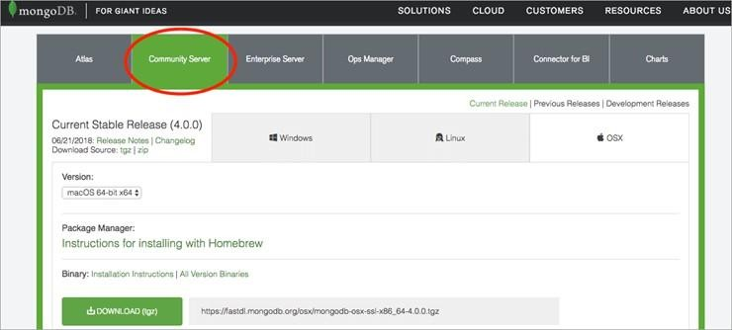

Windows [64-bit] Windows [32-bit] Installation Guide On Windows
Follow the below steps to install the proposed file:
Step 1: Open the file. We have installed for 64-bit version with the name as
“MongoDB-win32-x86_64-2008plus-ssl-v3.4-latest-signed”. It is saved in the Local Disk C:/, click on the file where you’ve saved it to start the wizard.
Figure 2:
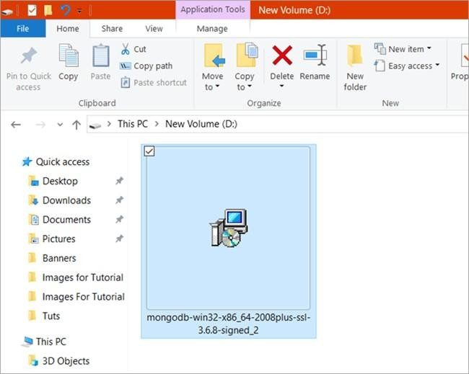

Step 2: Click “Next“. Figure 3
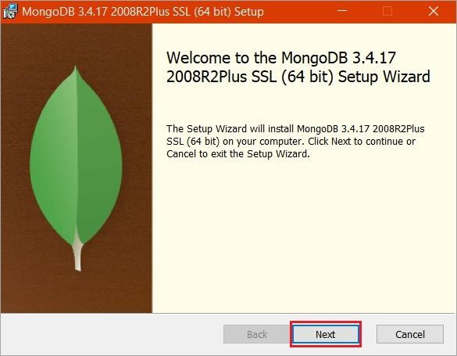

Step 3: Tick the check box next to ‘I accept the terms in the License Agreement’ and again click on “Next“. Figure 4:

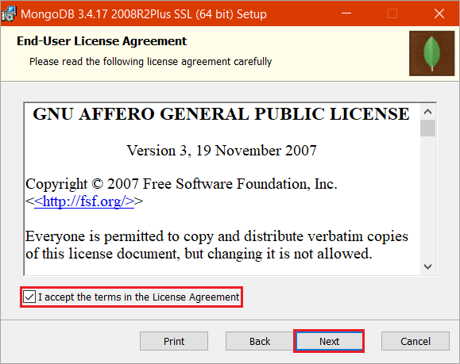

Step 4: Click “Complete” to install all the features of MongoDB. As for “Custom”, this option would be used to install only the specific components of MongoDB and also if a user wants to change the location of where the installation must be done.
Figure 5
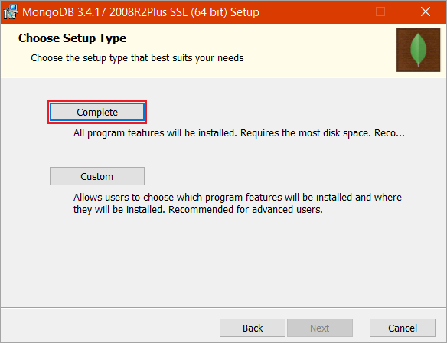

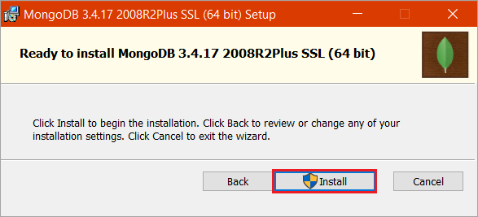
Step 5: Click “Install” to begin the installation drive. Figure 6

Figure 7
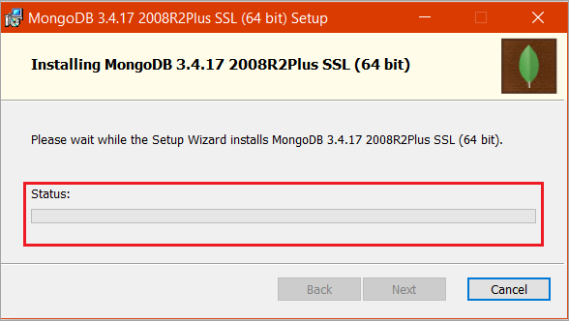

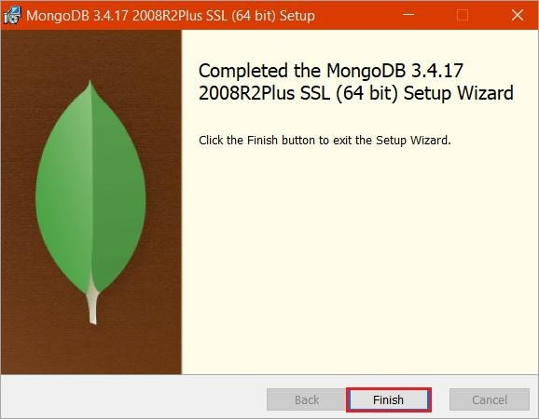
Step 6: After the installation has been finished. Simply, click “Finish“. Figure 8:

